Lab no 3

Slide (4)

1. SELECT ename, job, deptno FROM emp

WHERE job='CLERK';

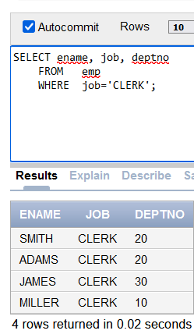

2. SELECT ename, job, deptno FROM emp

WHERE ename = 'JAMES';

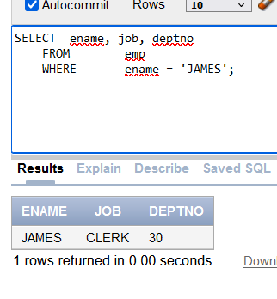

3. SELECT ename, sal, comm FROM emp

WHERE sal<=comm;

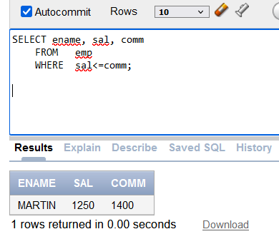

4. SELECT ename, sal FROM emp

WHERE sal BETWEEN 1000 AND 1500;

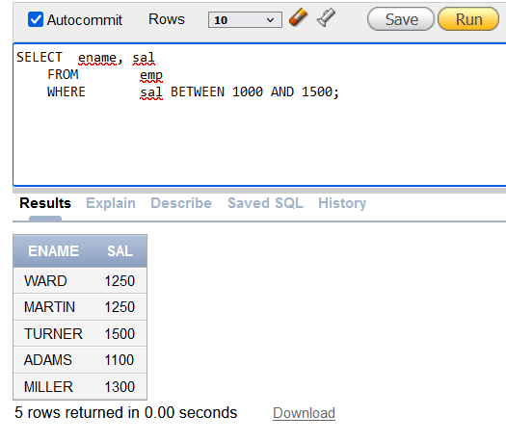

**5.** **SELECT empno, ename, sal, mgr FROM emp**

**WHERE mgr IN (7902, 7566, 7788);**

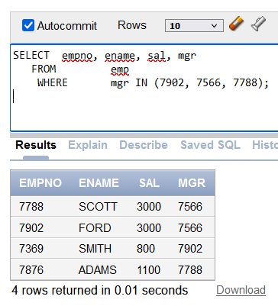

**6.** **SELECT ename FROM emp**

**WHERE ename LIKE '_A%';**

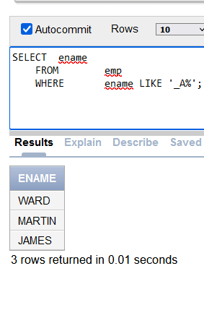

**7.** **SELECT ename, mgr FROM emp**

**WHERE mgr IS NULL;**

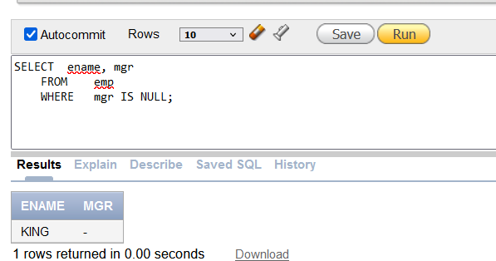

**8.** **SELECT empno, ename, job, sal FROM emp**

**WHERE sal>=1100 AND job='CLERK';**

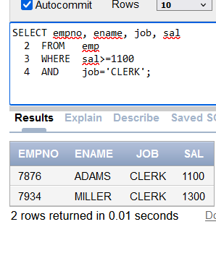

**9.** **SELECT empno, ename, job, sal FROM emp**

**WHERE sal>=1100 OR job='CLERK';**

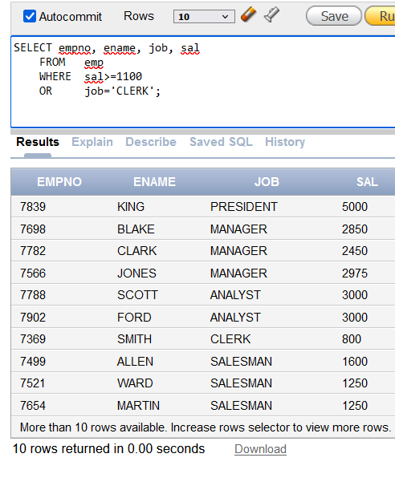

**10.** **SELECT ename, job FROM emp**

**WHERE job NOT IN ('CLERK','MANAGER','ANALYST');**

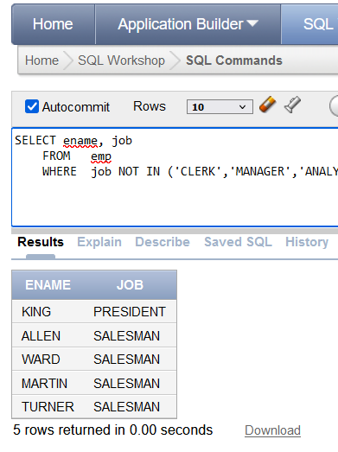

**11.** **SELECT ename, job, sal FROM emp WHERE (job='SALESMAN’ OR job='PRESIDENT')**

**AND sal>1500;**

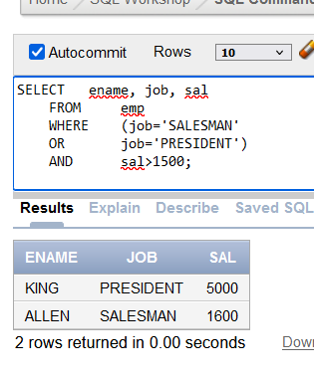

**12.** **SELECT ename, job, sal FROM emp**

**WHERE job='SALESMAN'**

**OR job='PRESIDENT'**

**AND sal>1500;**

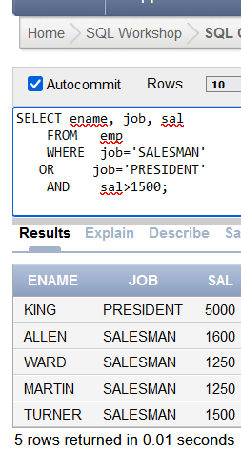

**13.sort**

**SELECT ename, job, deptno, hiredate FROM emp**

**ORDER BY hiredate;**

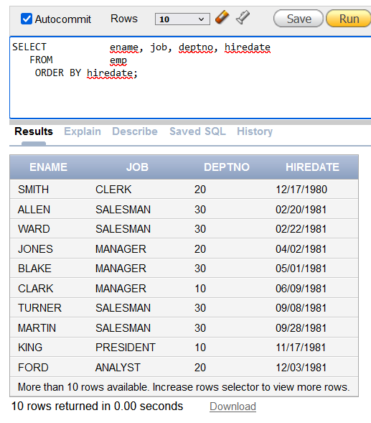

**14.** **SELECT ename, job, deptno, hiredate FROM emp**

**ORDER BY hiredate DESC;**

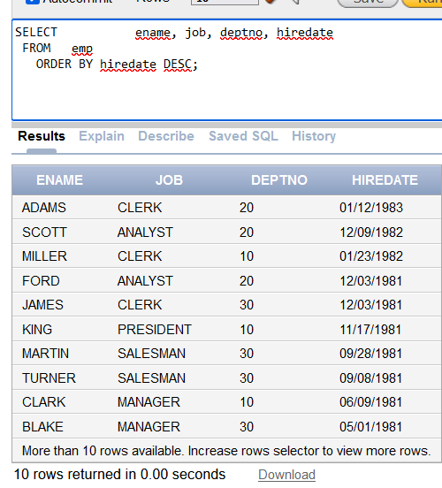

**15.** **SELECT empno, ename, sal*12 annsal FROM emp**

**ORDER BY annsal;**

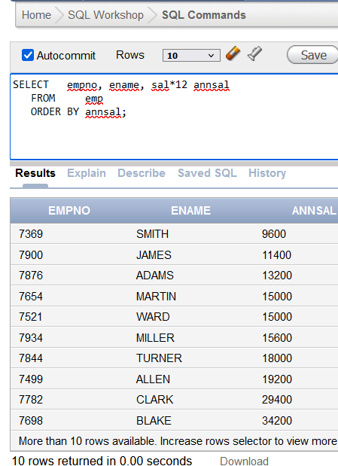

**16.** **SELECT ename, deptno, sal FROM emp**

**ORDER BY deptno, sal DESC;**

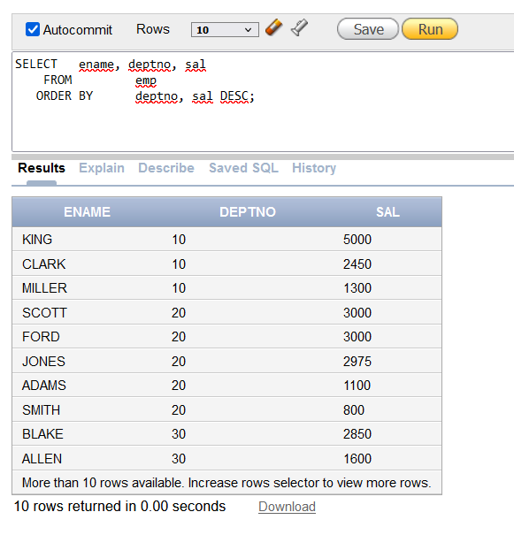

**Slide(6)**

**1.** **SELECT empno, ename, deptno FROM emp**

**WHERE ename = 'blake';**

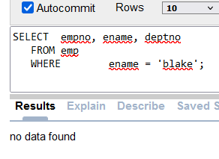

**2.** **SELECT empno, ename, deptno FROM emp**

**WHERE LOWER(ename) = 'blake';**

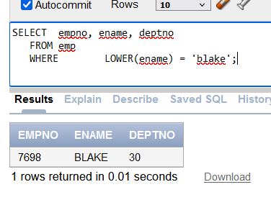

**3.** **SELECT ename, CONCAT (ename, job), LENGTH(ename), INSTR(ename, 'A') FROM emp**

**WHERE SUBSTR(job,1,5) = 'SALES';**

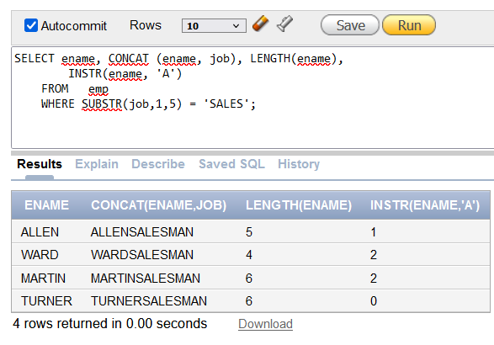

**4.** **SELECT ROUND(45.923,2), ROUND(45.923,0), ROUND(45.923,-1) FROM DUAL;**

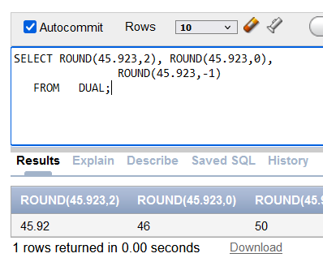

**5.** **SELECT TRUNC(45.923,2), TRUNC(45.923),**

**TRUNC(45.923,-1) FROM DUAL;**

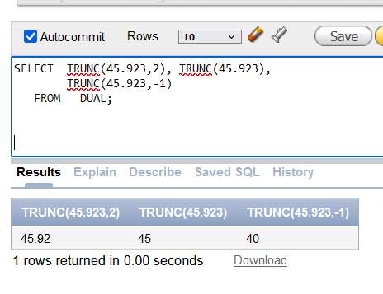

**6.** **SELECT ename, sal, comm, MOD(sal, comm) FROM emp**

**WHERE job = 'SALESMAN';**

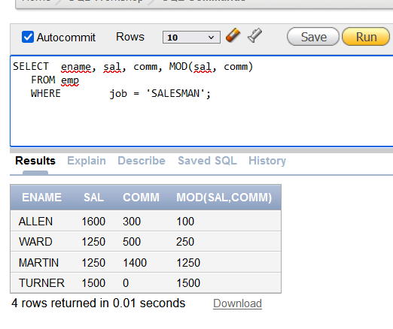

**7.** **SELECT ename, (SYSDATE-hiredate)/7 WEEKS FROM emp**

**WHERE deptno = 10;**

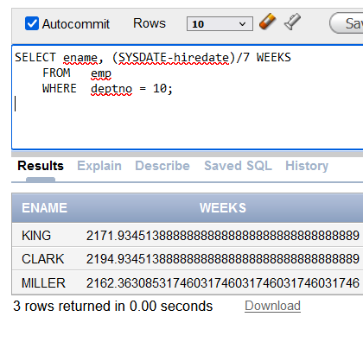

**8.** **SELECT ename, TO_CHAR(hiredate, 'fmDD Month YYYY') HIREDATE**

**FROM emp;**

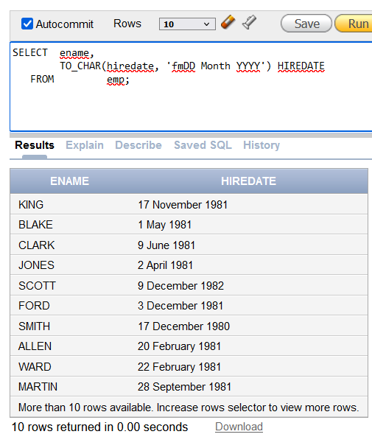

**9.** **SELECT TO_CHAR(sal,'$99,999') SALARY FROM emp**

**WHERE ename = 'SCOTT';**

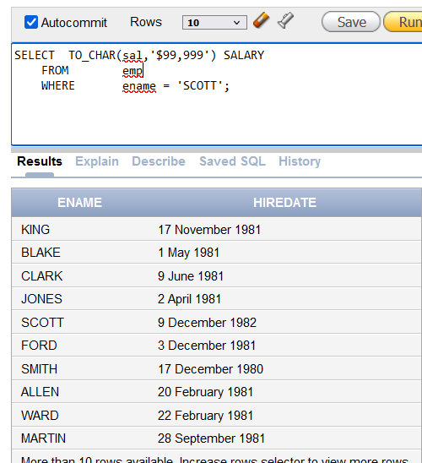

**10.** **SELECT ename, sal, comm, (sal*12)+NVL(comm,0)**

**FROM emp;**

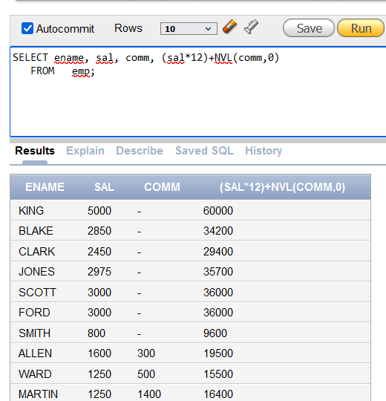

**11** **SELECT job, sal,**

**DECODE(job, 'ANALYST', SAL*1.1,**

**'CLERK', SAL*1.15,**

**'MANAGER', SAL*1.20,**

**SAL)**

**REVISED_SALARY FROM emp;**

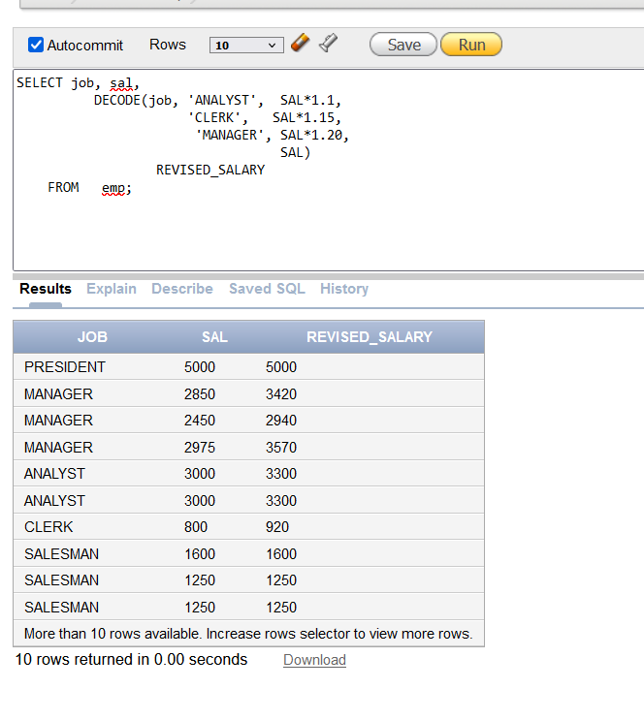

**12.** **SELECT ename, NVL(TO_CHAR(mgr),'No Manager')**

**FROM emp WHERE mgr IS NULL;**

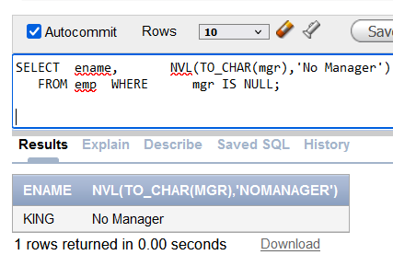

Slide (8 )

**1.SELECT AVG(sal), MAX(sal),MIN(sal), SUM(sal)**

**FROM emp WHERE job LIKE 'SALES%';**

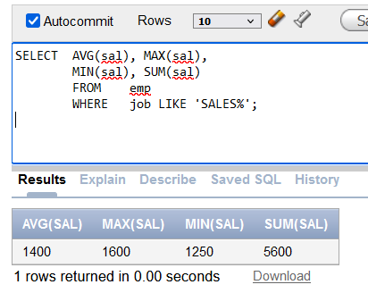

**2.** **SELECT MIN(hiredate), MAX(hiredate) FROM emp;**

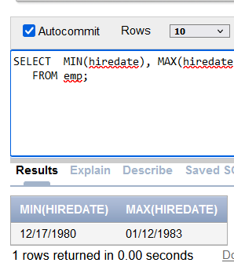

**3.** **SELECT COUNT(*) FROM emp**

**WHERE deptno = 30;**

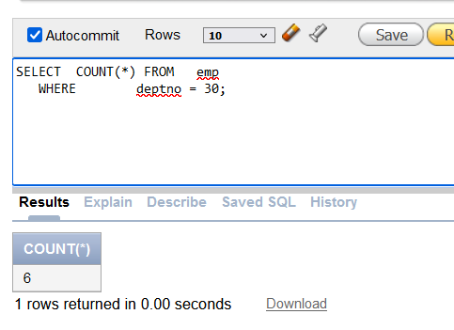

**4.** **SELECT COUNT(comm) FROM emp**

**WHERE deptno = 30;**

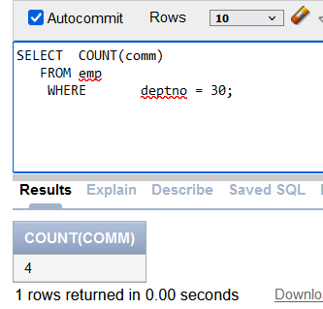

**5** .**SELECT AVG(comm) FROM emp;**

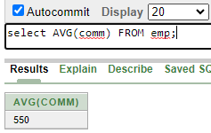

**6. SELECT AVG(NVL(comm,0))**

**FROM emp;**

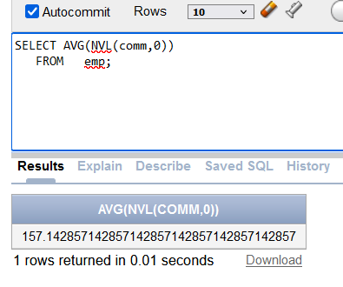

**7. SELECT deptno, AVG(sal)FROM emp**

**GROUP BY deptno;**

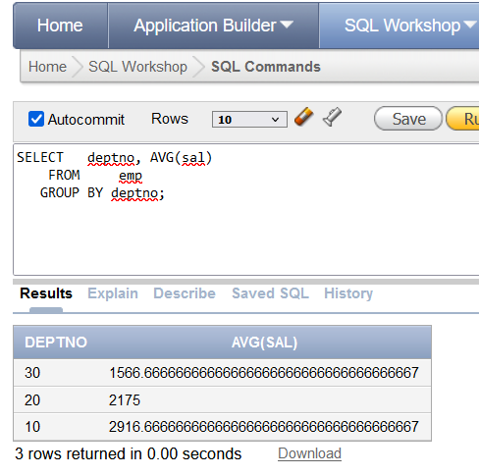

**8.** **SELECT AVG(sal)FROM emp**

**GROUP BY deptno;**

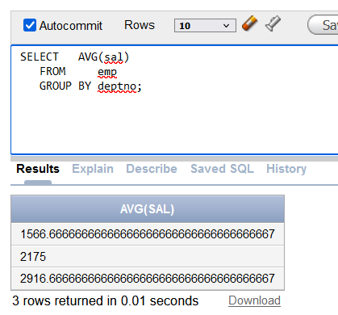

**9.** **SELECT deptno, job, sum(sal) FROM emp GROUP BY deptno, job;**

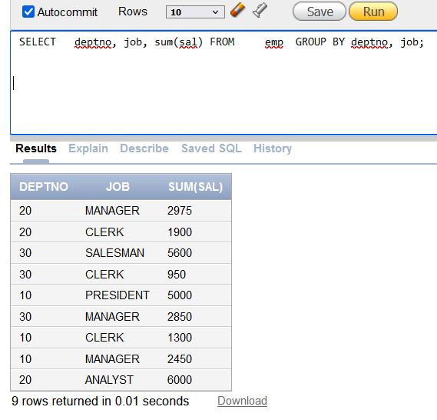

**10.** **SELECT deptno, max(sal)FROM emp**

**GROUP BY deptno HAVING max(sal)>2900;**

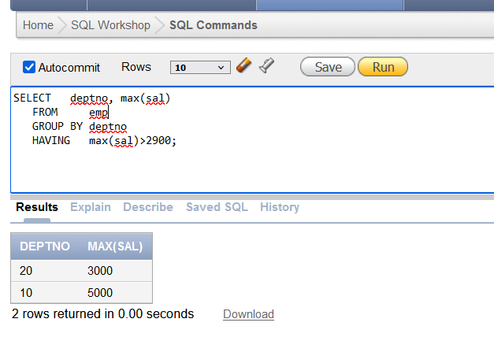

**11.** **SELECT job, SUM(sal) PAYROLL FROM emp WHERE job NOT LIKE 'SALES%'**

**GROUP BY job HAVING SUM(sal)>5000**

**ORDER BY SUM(sal);**

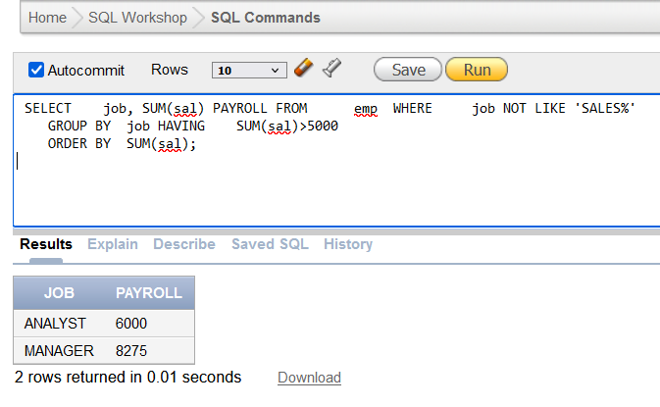

**12.** **SELECT max(avg(sal))FROM emp**

**GROUP BY deptno;**

